|  |  |  |  |
| --- | --- | --- | --- |
|  |  |  | |
|  | |  | |
| IWD Assignment 2 Documentation  *NZ Painting* | | | |
|  |  | |  |
|  |  | |  |

Bo Bi, ID: 1450432

Yingxin Liu, ID: 1465906

Chang Liu, ID: 1441639

# Website introduction

We built this website, NZ Painting Creations Studio, to give viewers who might be interested in artwork paintings or need them for business or home decoration, a general understanding of the company’s history and work.

Github url: <https://github.com/CynthiaaLIU/WebAssignment2>

# Site map

This website has 5 pages.

a. Index page.

The homepage shows some general info about the company, its work field, history, and some pictures of its artwork.

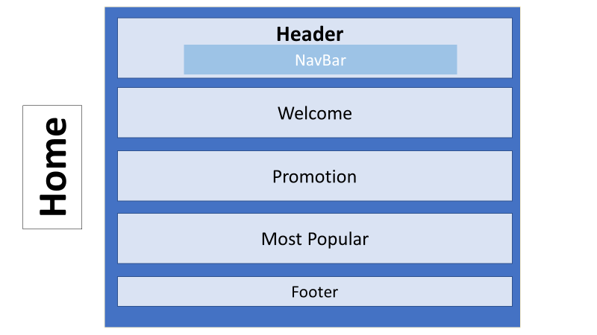

b. Artworks.

This page is filled with some pictures of the company’s fine work.

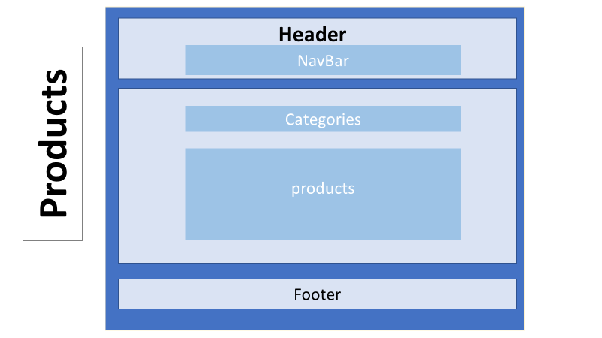

c. Signup

On this page, people can sign up with their email address to receive latest news from the company.

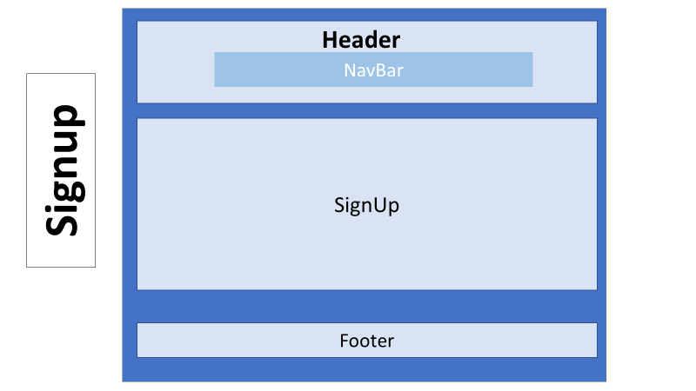

d. About

This page shows the company’s history, contact info (location, phone number, email address) and a location map.

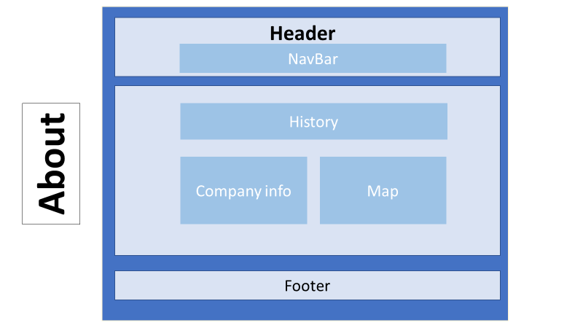

e. Shopping cart

Allow users to interactively add, and remove items from the shopping cart.

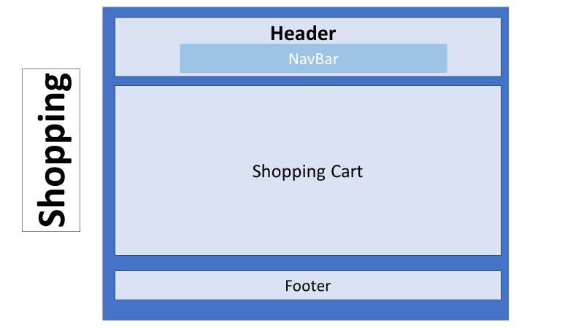

# Functions

This website has 5 pages. All the pages have a header, which include a navigate bar, and a footer in the bottom. Each page has different content in the middle of the page.

a. Index page.

The homepage has three parts. The first page shows some general info about the company, its work field, history. The second and third part provide the discount paintings and the most popular paintings respectively.

b. Artworks.

We exhibit all the products on this page, and divide them to five categories: abstract, ink painting, landscape, pop art and portrait. We design a list of categories to help you browse the specific category.

When you hover on the picture, the name, description size and price will show up. We provide a link via “Buy It” button, and you can add it to your shopping cart when you click on the “Buy It” button.

c. Signup

On this page, people can sign up with their email address to receive latest news from the company. The website can check the format of the users’ information automatically, such as the length of the name, the format of the email address.

d. About

This page contains the necessary information of NZ Painting Creation Studio. Including their history, contact info and a location map. The location map is built based on google map. The customers can use it to zoom in, zoom out the map by using the plus, minus button, and view the terrain, satellite map by the terrain, satellite button.

e. Shopping cart

Allow users to interactively add, and remove items from the shopping cart.

# Business Purposes

a. Index page.

This page aims at attracting customers with the discount items and the most popular items. It’s the homepage of the website, the customers who are interested in the cheap or popular products may also browse other products and buy more.

b. Artworks.

This page helps customer to choose the categories them like and provide the products precisely to attract customers and make them easy to buy the them. All the information they need, such as the name, description, size and price, is shown on the picture when they hover on it, this function helps the customers to make the decision on whether they want to buy it or not.

c. Signup

On this page, people can sign up with their email address to receive latest news from the company. We can send our ads precisely to the target customer. It is a good way to promote the sell and to keep our customers in touch.

d. About

This page, as the provision of the respectable past, can be regarded as an advertise of the NZ Painting Creation Studio. We can attract customers with our glorious history. And we provide the location, phone number, email address to help the customer to contact us. And the google map help users to know how to come to our company to view the paintings by their own.

e. Shopping cart

Allow users to interactively add, and remove items from the shopping cart.

# 5. Page Design

Each page has a header, footer, and Nav. Each page follows the layout so that we make sure every page has a same style.

Header

Footer

Navi

# 6. Script code explanation

We created a function called qushuju(). In this function, we passed 3 parameter to the function, which are the id number, objet name and where to put data in. This is a very important function that we use for all pages. You can see I used a lot for the home page and product page.

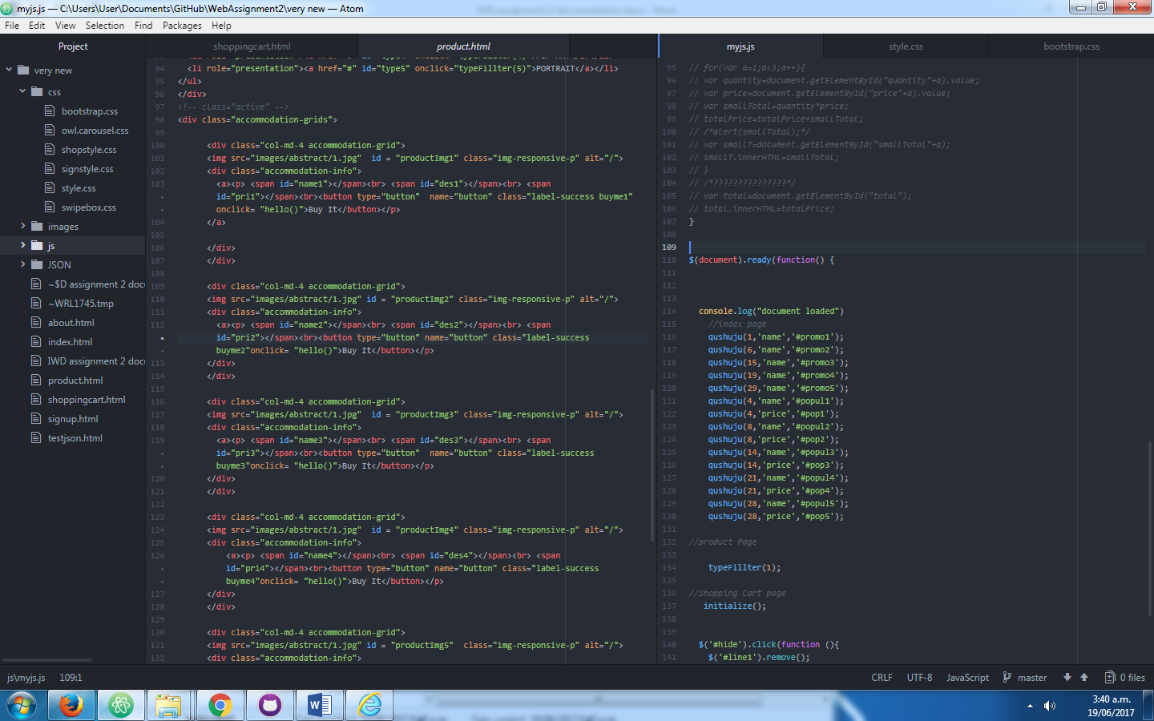

This is the function. We use AJAX to retrive data from web service (github) as our database. We use XMLHttpRequest() function to get data, and put data in 2 ways. First way, if we have the third parameter, we will directly put data to where we define. If we didn’t define, we can use reture to receive it.

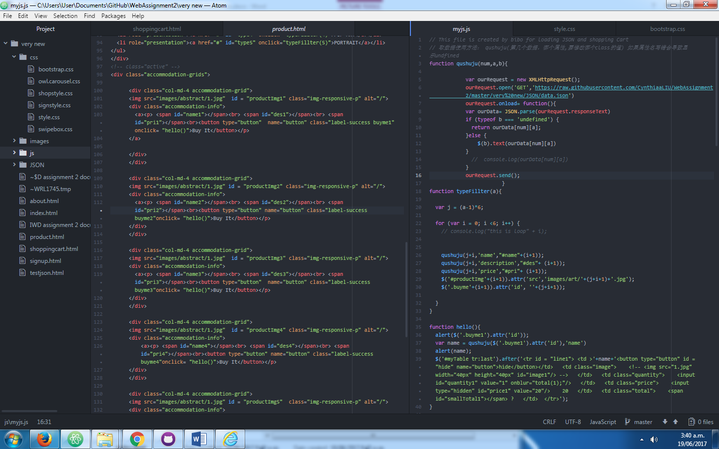

Here is another code for product page. We use a for loop at this page to put all the data from JSON file to the correct place. Also setup img source etc.

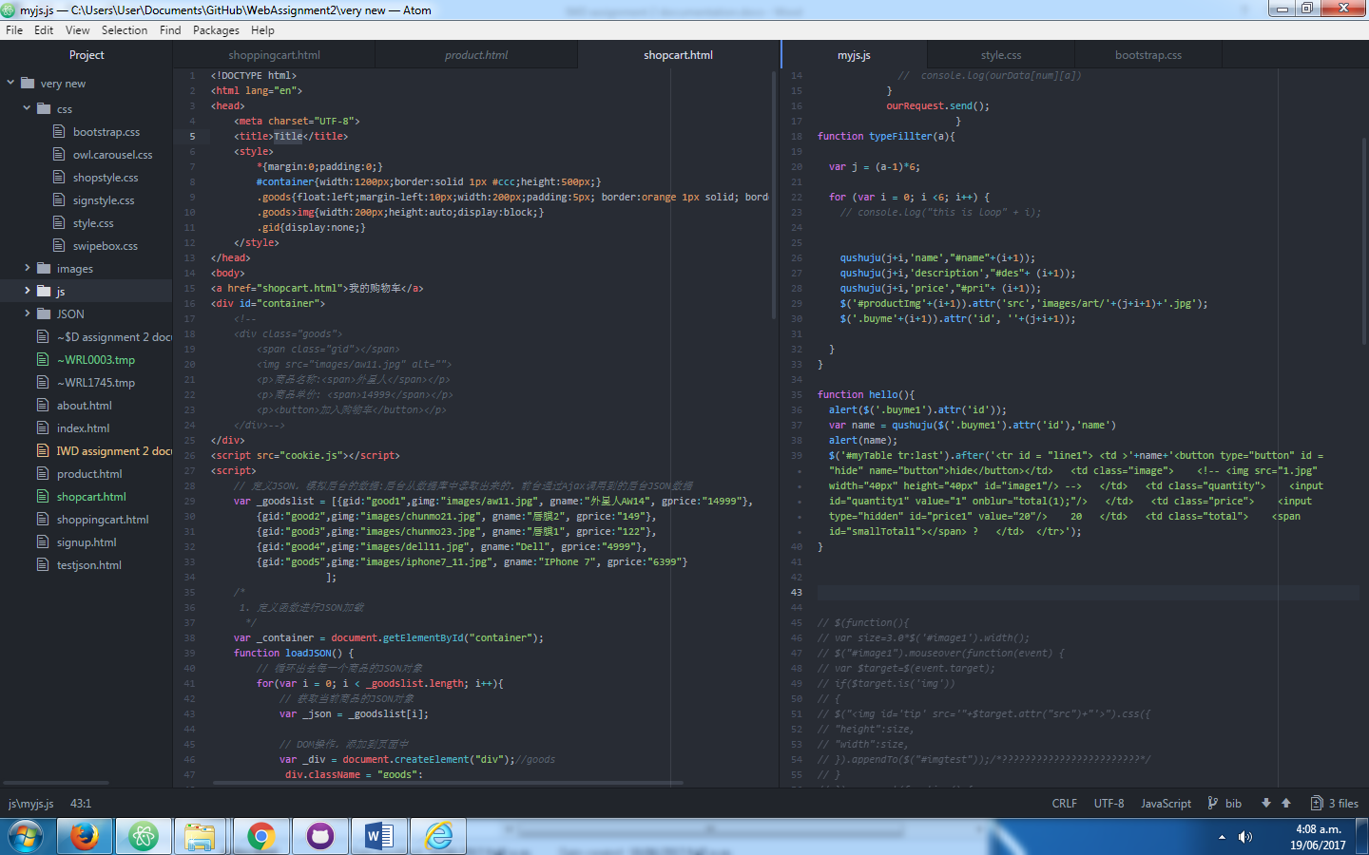

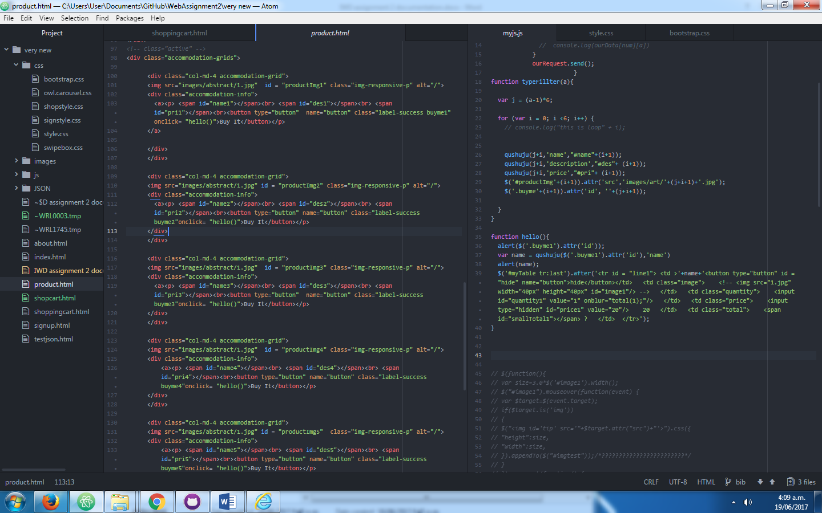

# 7. Testing on three browsers

We tested with chrome, firefox and Internet explorer. All 3 browsers works well. Here is a screen shot from each browser.

1. Google Chrome:

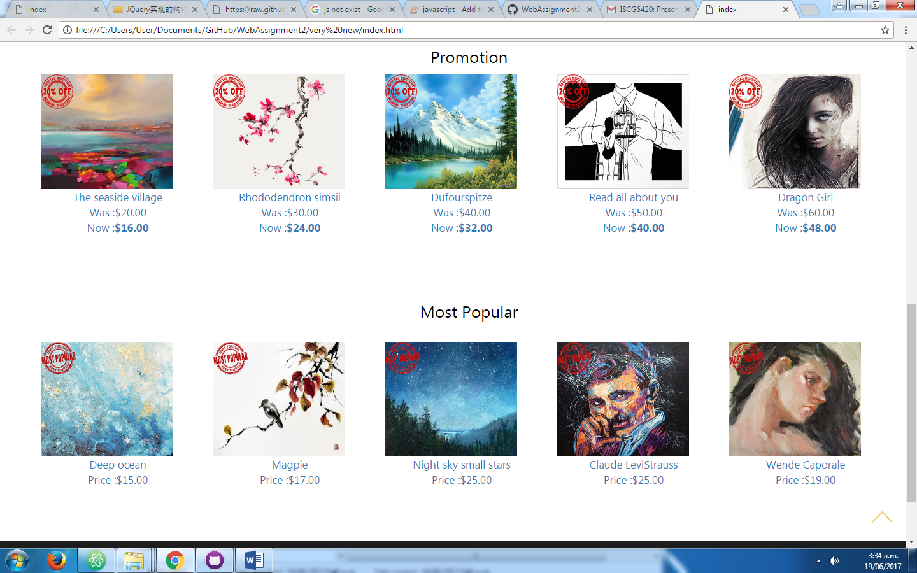

1. Mozilla Firefox:

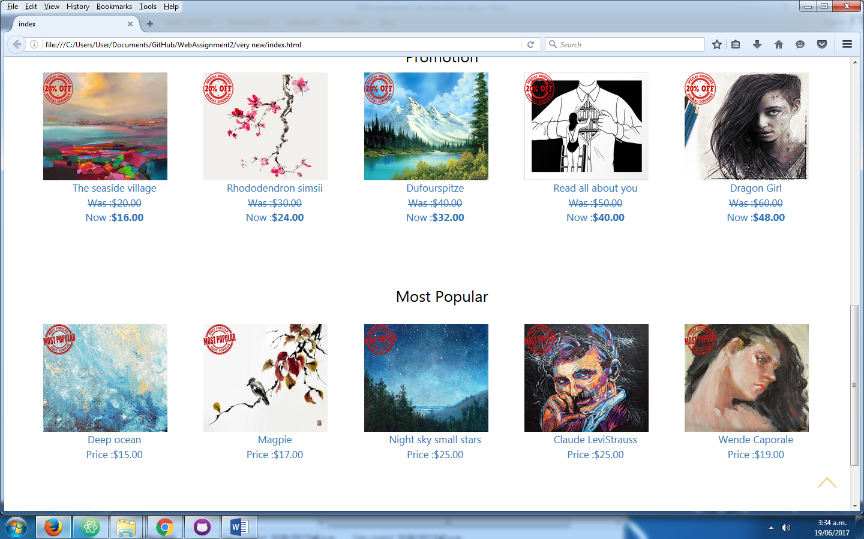

1. Internet Explorer:

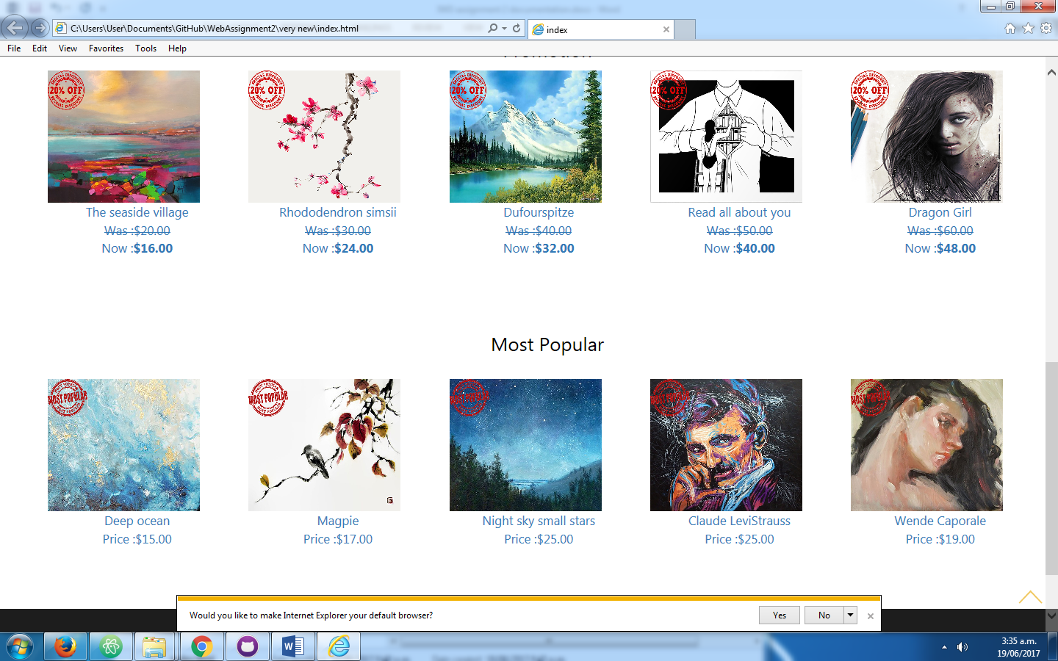

# 8. Future improvements

Animations: we found that if we add some animations to the website, for instants a small picture come out after click “buy” will be more fun and make users easier to understand where the items has gone.

JQuery: we used a lot of jquery in this assignment. However, we still struggled in certain method, such as append to a table. We need more exercise on it.

# 9. Reference

Bootstrap

Jquery

Ajax

# Appendix 1

**IWD Assignment - Individual Contribution Review**

This form is to be completed **once** by the group as a whole and included with your documentation.  You may use several forms if necessary. If the form is missing or empty, it will be assumed that all students contributed equally.

**Each group member must sign this form as evidence that they agree with its content.**

**Name_****Yingxin Liu____**

**Signature__ Yingxin Liu ________________**

###### Name___Bo Bi___

###### Signature___Bo Bi_________________________

**Name___Chang Liu____**

**Signature____Chang Liu___________________**

Enter the task and/or sub-topic and the name of the student to whom it was assigned. Should a task have been shared, then enter an agreed estimate of percentage involvement beside each name. If only one name appears then it is assumed that the individual contributed 100%. Each task should require approximately the same amount of effort.

|  |  |  |
| --- | --- | --- |
| Task/Sub-topic | Names | **%** |
| Home page | Chang Liu | 18 |
| About page | Chang Liu | 15 |
| Products page | Bo Bi | 20 |
| Shopping cart | Bo Bi | 13 |
| Signup page | Yingxin Liu | 18 |
| documentation | Yingxin LIu | 15 |